Figure 3_1

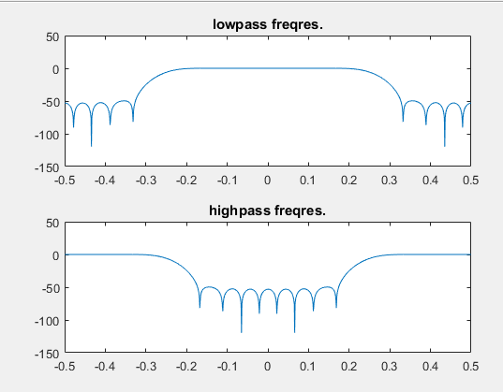

Figure 3_2

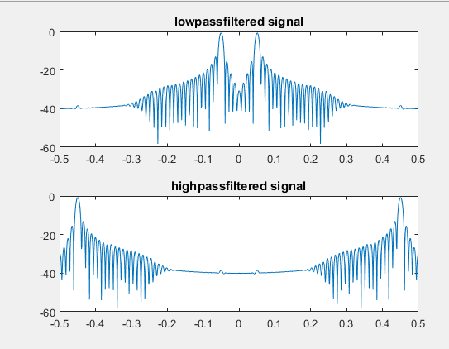

Figure 5

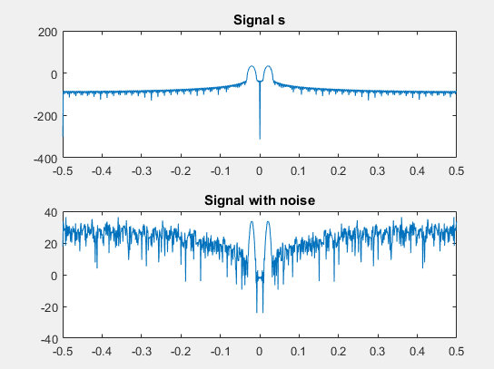

Figure 6_1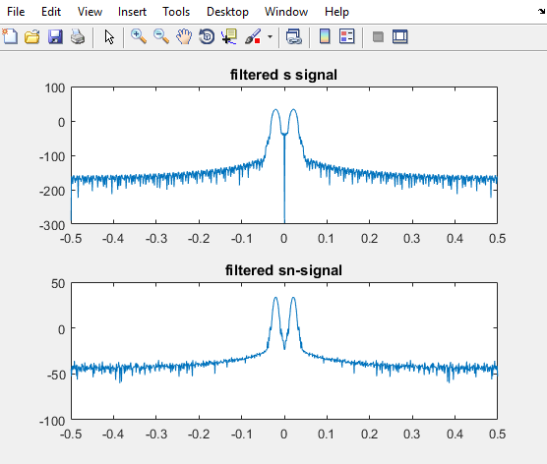

Figure 6_2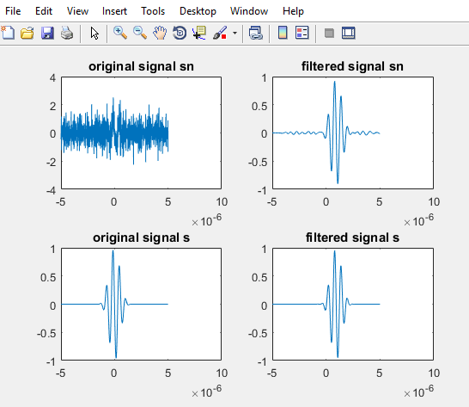

***Downsample the signal by a factor two. Plot the downsampled signal and the corresponding power spectrum in Figure 4. What happens? Can you explain why?***

* %when we downsample with 2 we remove every other stick in the signal s. So by downsampling with 2 we remove the stick that is zero if we downsample by 1, then we remove the amplitude of the signal and we get distortion of the signal. We get aliasing, the high freq. Tops will then be left out and be included in the signale as 1-fs/2